Digital design
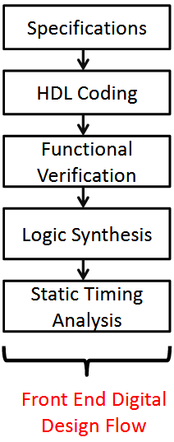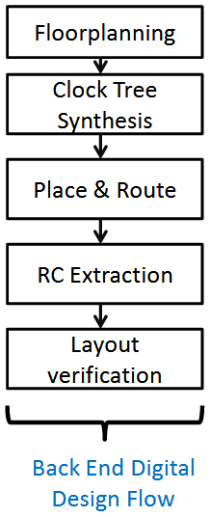

Logic synthesis : Synopsys Design compiler or Cadence RTL compiler
Static timing analysis : Synospys PrimeTime
Place and route : Cadence encounter or synopsys IC compiler
Rc extraction: Synopsys Star RXCT
Layout / verification : Calibre (Physical design ) and Incisive

GATE LEVEL SYNTHESIS
Gate level synthesis involves implementing the behavior of the circuit (described
by a Verilog model) using standard gates. In gate level synthesis, the
Verilog file is synthesized into a netlist file which includes standard gates and their delays. In any design process the simulation of this gate
-
level netlist will eventually
shows
the success or failure of the design. Along with the netlist
file the synthesis script also generates timin
g
-
report, area report and power report. The timing
report is a critical piece of information. It gives details about critical path which
indicates
whether the circuit meets the timing/frequency requirements.

Link the following libraries in the current working directory:

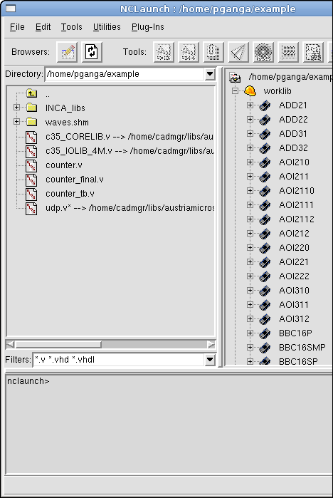

Synthesis is the process of turning behavioral
Verilog into structural Verilog

Generic map

http://perso.telecom-paristech.fr/~guilley/ENS/20161206/TP/tp_syn/doc/syntut.pdf

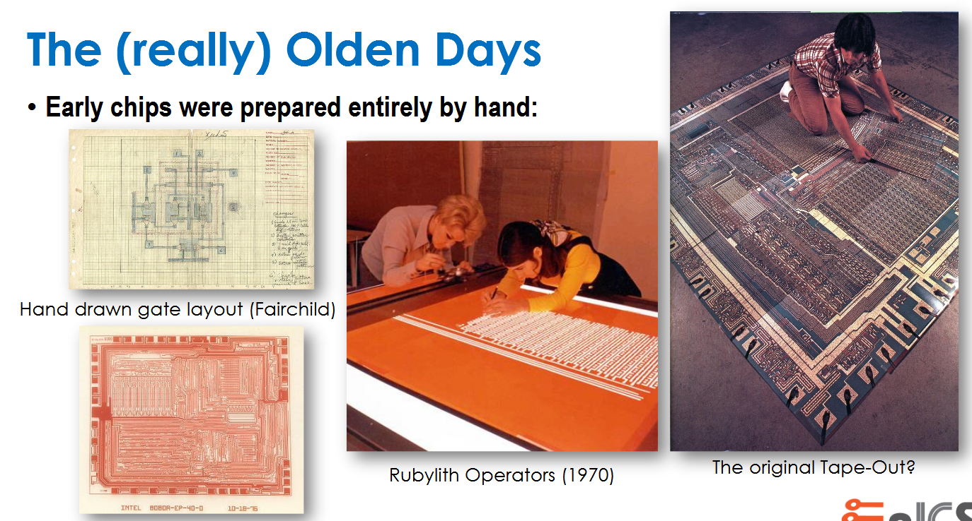

Gate level simulation

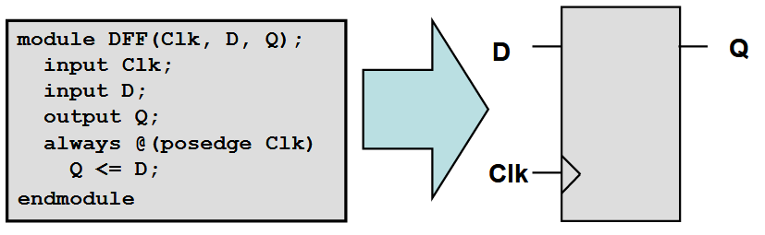

http://viplab.cs.nctu.edu.tw/course/VLSI_SOC2009_Fall/CBDF.pdf

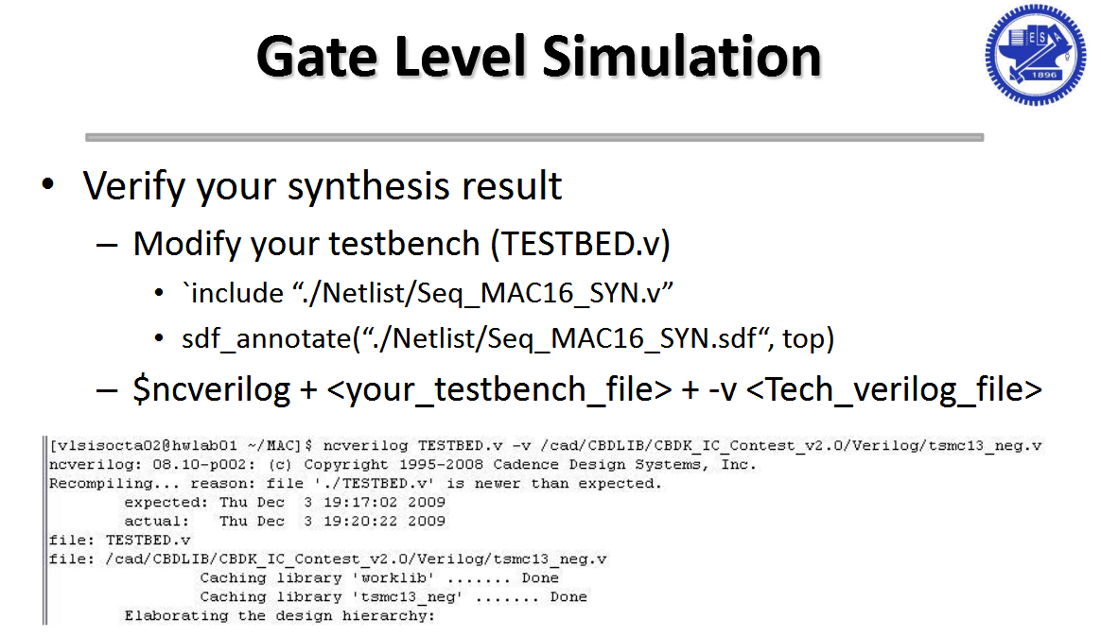

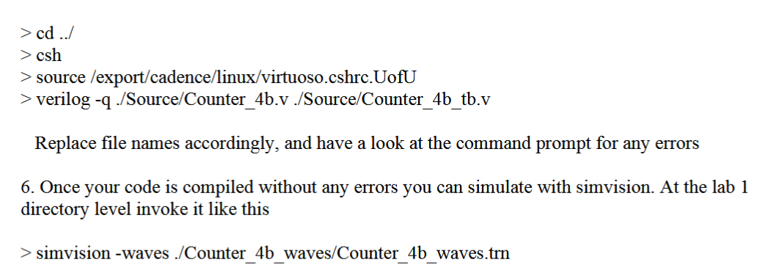

http://www.ece.utep.edu/courses/web5375/Labs_files/verilog-xl_simvision_tutorial.pdf

http://www-scf.usc.edu/~ee577/tutorial/cadence_tut3.pdf

Add IUS/tools/lib to LD_LIBRARY_PATH environment variable.

setenv LD_LIBRARY_PATH $IC_HOME/tools/lib/

export CDS_ROOT=/home/frax/edatools/virtuoso

